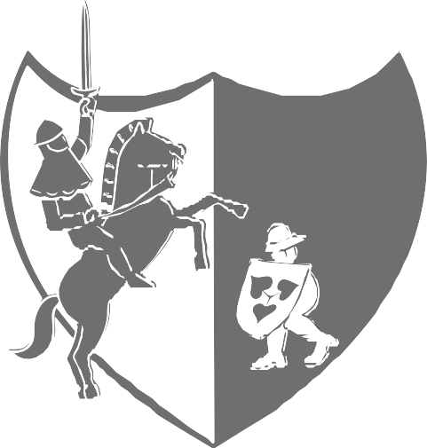
THE CUP

of ŘÍČANY

2024

22 ^{nd} year – extraordinary term

29. 6. – 6. 7. 2024

5. 7. 2024 Blitz tournament
Municipal cultural centre Labuť Říčany
The Chees Club Říčany 1925 in cooperation with the Municipality of the town of Říčany and the Central Bohemian Chess Federation invites friends of chess to Říčany for an open chess tournament for all ages.

The Prize fund 60 400 CZK

Venue: Kulturní centrum Labuť Říčany (Municipal cultural centre),
street 17. listopadu 214, 251 01 Říčany
Organizer: Klub šachistů Říčany 1925
Deadline for Entries: Until 25. 6. 2024. Later entries only upon prior agreement.
Entries: E-mail: open@sachyricany.cz, Marie Jiroušková, tel.: 606 420 407 Running information: www.openricany.cz
The tournament director reserves the right to limit the entries of players with FIDE ELO less than 1750 into the OPEN A tournament.
Entry Fee: OPEN A: 1100 CZK, players IM a GM 0 CZK, above FIDE ELO 2300 inclusive: 500 CZK, above FIDE ELO 2200 inclusive: 800 CZK, under FIDE ELO 1750: 1500 CZK,
under FIDE ELO 1650: 1800 CZK, under FIDE ELO 1500: 2800 CZK.
Winners of those SŠS divisional championships for the year 2023, whose results were counted in the Czech LOC, have a discount of 100 CZK.
OPEN B: 900 CZK
The Entry fee can be sent to bank account nr. 2900575300/2010 until 22.06.2024 including the player´s name in message for recipient and player´s date of birth as variable symbol (DDMMYYYY). Players who will pay to the organizer´s bank account by 1 June, will have the entry fee reduced by 100 CZK.
Non-active players at the date of beginning, according to the database of the Chess Federation, with additional fee + 150 CZK for both tournaments.
Discounts: (only one discount can be applied):
Seniors born 1959 and older, juniors born 2006 and younger
-200 CZK
Home-based players -200 CZK
Players participating 5x and more -100 CZK
Players participating 10x and more -200 CZK
Players participating 20x and more -300 CZK
Disabled players -200 CZK
Format: 9 round Swiss system, time control 90min for the game
and 30 sec/move for each player
Waiting time: 60 minutes
ELO Evaluation: OPEN A i OPEN B will be registered at National Rating and FIDE ELO.
Standings criteria: 1. Points, 2. Middle Buchholz system, 3. Buchholz system, 4. Progress, 5. Random Draw.
The evaluation of ranking criteria for is according to the Competition Rules of the Czech Chess Federation.

FIDE OPEN A – Regional Championship Men, Women,
U 18, U 20 Players with ELO over 1750
Prize fund: 1. 20 000 CZK 2. 10 000 CZK 3. 5 000 CZK 4. 2 000 CZK
5. 1 500 CZK 6. 1 000 CZK 7. 900 CZK 8. 800 CZK
- 700 CZK 10. 600 CZK
Special prizes: Best junior (born 2006 and younger) 500 CZK Best senior (born 1959 and older) 500 CZK Best player to ELO FIDE 1 900 500 CZK
Best player FIDE 1901 – 2100 500 CZK
Best player FIDE 2101 – 2200 500 CZK

Special prizes cannot be cumulated with the prize fund. The player takes always only just the highest prize.

Special prizes: Best women 1. 1 500 CZK 2. 1 000 CZK 3. 500 CZK.
Best player from the club Říčany: 400 CZK Regional Championship Prize Fund:
Men 1. 2 500 CZK 2. 1 800 CZK 3. 1 300 CZK
4. 900 CZK 5. 500 CZK
Women 1. 1 500 CZK 2. 500 CZK
U 20 (r. 2005 a ml.) 1. 2 000 CZK 2. 1 000 CZK 3. 500 CZK
U 18 (r. 2007 a ml.) 1. 2 000 CZK 2. 1 000 CZK 3. 500 CZK

Games will be registered and available in PGN format on the website www.openricany.cz.
FIDE OPEN B – Players with ELO under 1900
Regional Championship WU 18, WU 20
Prize fund: 1. 3 000 CZK 2. 2 000 CZK 3. 1 500 CZK 4. 1 000 CZK
5. 900 CZK 6. 700 CZK 7. 500 CZK

Special prizes: Best player under ELO 1400 400 CZK
Best player ELO 1401 – 1600 400 CZK
Best player ELO 1601 – 1800 400 CZK Best senior (born 1959 and older) 400 CZK
Special prizes cannot be cumulated with the prize fund. The player takes always only just the highest prize.

Special prizes: Best player from the club Říčany 400 CZK
Best woman 400 CZK
Regional Championship Prize Fund:
WU 20 (born 2005 and younger) 1. 1 000 CZK 2. 500 CZK
WU 18 (born 2007 and younger) 1. 1 000 CZK 2. 500 CZK

Games in OPEN B will not be registered nor published.

Company Biomedica s.r.o. Praha will present small gifts to all participants.

Time schedule: Sa 29. 6. Registration 13.30–15.30
Opening ceremony 16.45
1 ^{st} round 17.00
Su 30.6. 2 ^{nd} round 9.30
3 ^{rd} round 15.00
Mo 1.7. 4 ^{th} round 17.00
Tu 2.7. 5 ^{th} round 17.00
We 3.7. 6 ^{th} round 17.00
Th 4.7. 7 th round 17.00
Fr 5.7. Blitz tournament 9.30
8 ^{th} round 15.00
Sa 6.7. 9 ^{th} round 9.30

Closing ceremony: 30 min. after the end of the last round
Accomodation: Accomodation is not provided.

Arbiter: Tadeáš Baláček
Tournament director: Ing. Jaroslav Říha, tel.: 603 569 813, riha.sachy@volny.cz
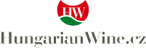
Special provisions: The OPEN Říčany prize, which is not collected by the player at the announcement, is forfeited to the organizer. The KP prize, which is not collected by the player at the time of the announcement, is forfeited to the SŠS. The participants of the tournament agree, without further notice, to the publication of their name in the results lists in printed form and on the Internet and to the free use of their image or likeness as part of any image recording or transmission of the tournament for commercial or promotional purposes. The Director reserves the right not to accept players who have had bad experiences in previous years. A refundable deposit of 1000,- CZK will be collected from players who did not excuse themselves in the last round in the previous year (to be refunded after the last round in case of a smooth run)

 | Winners of the Cup of the town of Ricany
1. year | Jana Jacková | 56 participants
2. year | Radoslav Doležal ml. | 66 participants
3. year | Jan Balhar | 58 participants
4. year | Tomáš Vojta | 88 participants
5. year | Ivan Hausner | 127 participants
6. year | Marek Vokáč | 146 participants
7. year | Marek Vokáč | 142 participants
8. year | Tomáš Kulhánek | 149 participants
9. year | Jan Sodoma | 166 participants
10. year | Tomáš Vojta | 166 participants
11. year | Ondřej Mejzlík | 136 participants
12. year | Tomáš Kulhánek | 165 participants
13. year | Vojtěch Plát | 159 participants
14. year | Jan Krejčí | 119 participants
15. year | Jakub Půlpán | 156 participants
16. year | Vojtěch Plát | 138 participants
17. year | Richard Mládek | 150 participants
18. year | Sebastian Plishki | 137 participants
19. year | Rostislav Táborský | 144 participants
20. year | Jakub Vojta | 206 participants
21. year | Martin Horák | 198 participants

